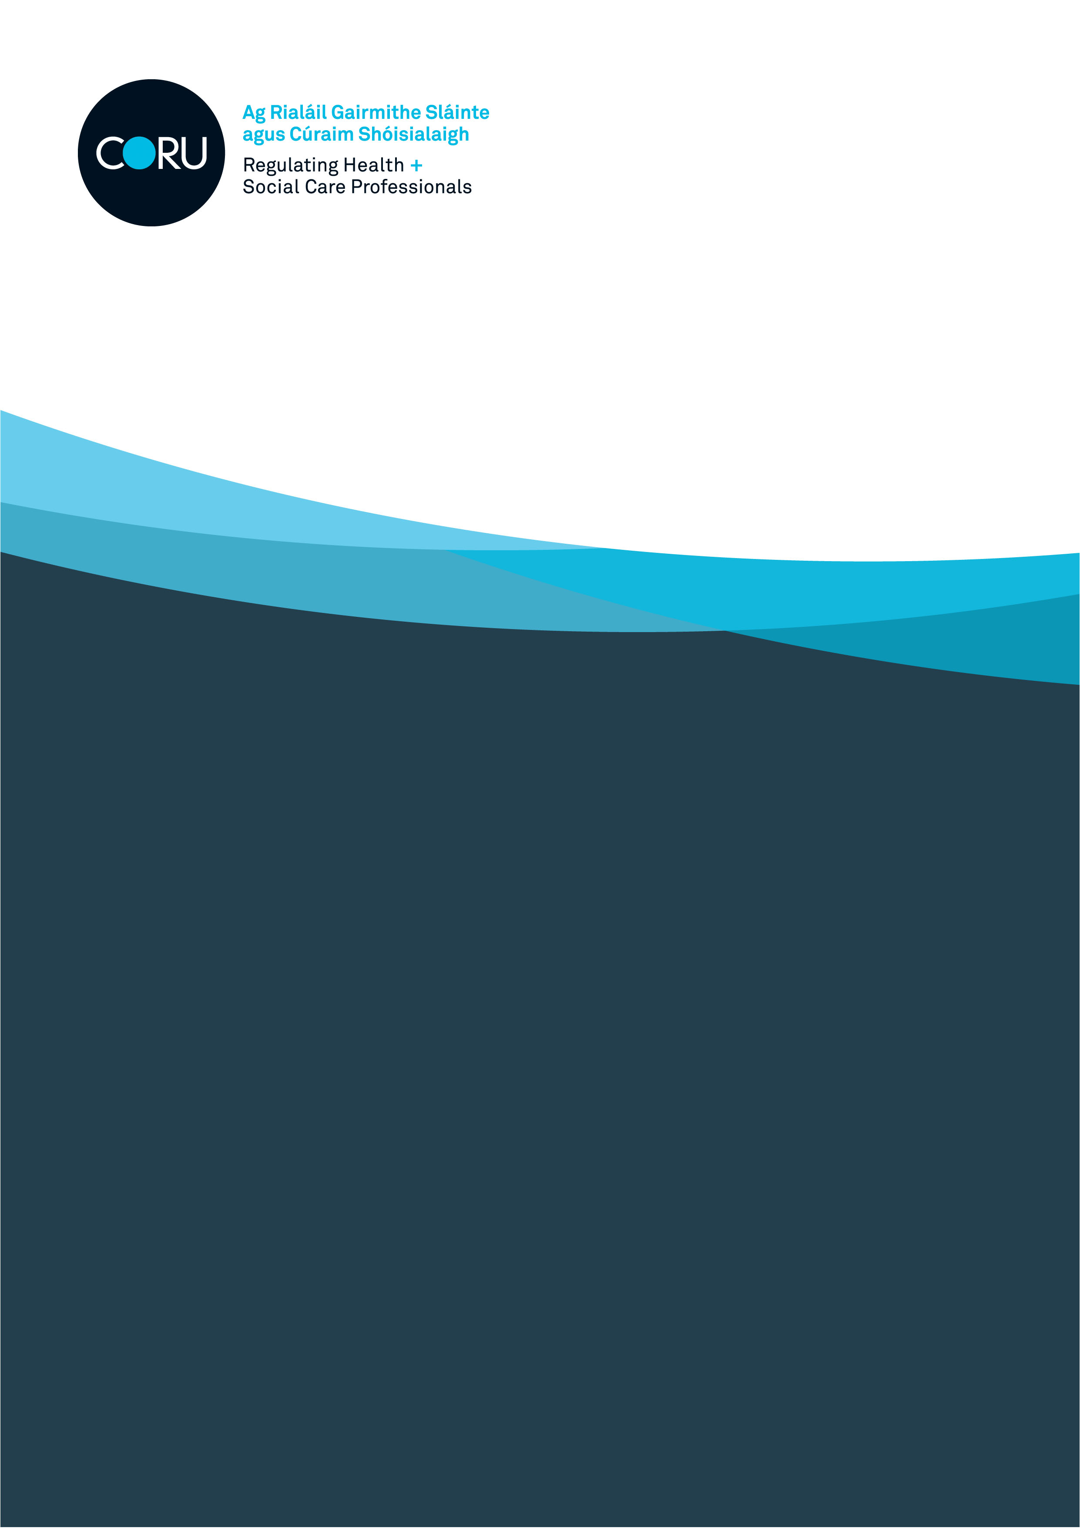

Audit, Risk and Governance Committee

Specifications and Requirements
July 2025

An Chomhairle um Ghairmithe Sláinte agus Cúraim Shóisialaigh
Health and Social Care Professionals Council

About CORU

CORU is Ireland’s multi-profession health regulator.

Our role is to protect the public by promotion high standards of professional conduct, education, training and competence through statutory registration of health and social care professionals.

CORU was set up under the Health and Social Care Professionals Act 2005 (as amended). It is made up of the Health and Social Care Professionals Council and the Registration boards, one for each profession named in the Act.

Audit, Risk and Governance Committee
The Audit, Risk and Governance Committee, is a Committee of Council and is in place to ensure that the best interests of CORU are achieved. Council has the remit of establishing an Audit, Risk and Governance Committee of at least three independent non-executive Board members. The Committee has written terms of reference which deal clearly with its authority and duties.

The function of the Committee
CORU’s statutory objective is the protection of the public. The Audit, Risk and Governance Committee is in place to ensure best practise are in place to ensure that the statutory objectives are carried out.

It is a requirement that at least one member of the Audit, Risk and Governance Committee has recent and relevant financial experience. Other members of the Audit, Risk and Governance Committee shall have experience in the core areas of its business including risk management, internal audit, governance, relevant technical or specialist issues, an understanding of the public sector environment, in particular the accountability structures, and current public sector reform initiatives.

Members are appointed to the Audit, Risk and Governance Committee for a period of four years and shall be eligible for reappointment up to four years, to a maximum of eight years in total.

Responsibilities for the role of Audit, Risk and Governance Committee member:
- Ensure that the strategic processes for risk, internal control and governance is in place.
- Ensure that the accounting policies, the financial statements, and the annual report of CORU, including the process for review of the financial statements prior to submission for audit, levels of error identified, and management’s letter of representation to the external auditors;
- To ensure that the planned activity and results of both internal and external audit is in place.
- To ensure that there is adequate response from management in relation to issues identified by audit activity, including external audit’s management letter of representation.
- To follow on assurances relating to the management of risk and corporate governance requirements for CORU.
- Review of CORU Corporate Governance Policies as they arise. The Audit, Risk and Governance Committee will also review the Protected Disclosure Procedures on an annual basis.
- The Audit, Risk and Governance Committee will also periodically review its own effectiveness and report the results of that review to Council.

Skills, Knowledge and Abilities:

Essential
You must have:
- A clear understanding of the importance of upholding public interest in high quality, efficient, consistent and fair regulation.
- A proven ability to contribute to objective decision-making by exercising sound judgement.
- Experience of effective leadership with a high degree of integrity.
- Good oral and written communication skills and interpersonal skills, including the ability to communicate professionally and build key relationships with a range of stakeholders.
- A proven track record of effective judgement, decision making, initiative and analytical thought.
- Critical thinking skills with a proven ability to grasp the detail of a wide range of issues.

Desirable
- Experience or demonstrated knowledge of similar Committee or
- Knowledge of financial procedures, audit, risk, internal audit, governance, relevant technical or an area relevant to this preferably in a regulatory environment.

Time commitment
The time commitment is estimated as being in the region 6-10 working days per annum, inclusive of meeting preparation time/reading and training.

Training
CORU provides induction training to members of the Audit, Risk and Governance Committee.

If you are successfully appointed to the Committee, induction training will be provided.

Fee and expenses
There is NO fee for attending Committee meetings. Travel and Subsistence expenses can be claimed through the finance Unit in Corporate Services for expenses incurred for travelling to meetings.

If you wish to apply for the role of Committee member of Audit, Risk and Governance, please complete the official application form, which is available on the vacancies section of the CORU website.

Please send the completed application form to appointments@coru.ie no later than 3 pm on Friday 05 September 2025.

For further information on CORU, please visit www.coru.ie.

Data Protection
CORU will process any personal data provided by you in connection with an application for this role in accordance with the General Data Protection Regulation and the Data Protection Acts 2018. The data will be kept for no longer that is necessary for the purposes for which that data are processed, and it shall be kept in a manner that ensure appropriate security of the data including the unauthorised or unlawful processing of data.

If your application is successful for the role as external member on the Audit, Risk and Governance Committee, then your personal data will continue to be processed in accordance for the specified reason of Committee membership and your data will not be held longer than is necessary.

CORU may disclose the data that you provided on the application form to external sources for the following reasons – where there is an external assessor assisting in the shortlisting for the vacancy on the Committee of Council to which you have applied, and to internal and external auditors.

